**Design and Implementation of Web-Based Office Service Feedback System using Sentiment Analysis**

Baslot Evander Jay Polinar

Bachelor of Science in Computer Science 3, Bohol Island State University-Bilar Campus, evanderjay.baslot@bisu.edu.ph

Fernandez Hani Jean Polestico

Bachelor of Science in Computer Science 3, Bohol Island State University-Bilar Campus, [hanijean.fernandez@bisu.edu.ph](mailto:hanijean.fernandez@bisu.edu.ph)

Mahinay Jovie Ann Baay

Bachelor of Science in Computer Science 3, Bohol Island State University-Bilar Campus, [jovieann.mahinay@bisu.edu.ph](mailto:jovieann.mahinay@bisu.edu.ph)

MAX ANGELO DAPITILLA PERIN (INSTRUCTOR)

Department of Computer Science, Bohol Island State University-Bilar Campus, [maxangelo.perin@bisu.edu.ph](mailto:maxangelo.perin@bisu.edu.ph)

The research is about Office Service Feedback System using Sentiment Analysis, the system aims to enhance the feedback collection process for office services by analyzing sentiment from user feedback. This system is utilized by a web-based type. By leveraging sentiment analysis techniques, the system provides valuable insights into user satisfaction and helps improve service quality.

CCS CONCEPTS • Software and its Engineering • Software creation and management• Designing software

Additional Keywords and Phrases: Sentiment Analysis, Office Service, Feedback, Web-based

ACM Reference Format:

Evander Jay Baslot, Hani Jean Fernandez, Jovie Ann Mahinay, MAX ANGELO DAPITILLA PERIN. 2024. Design and Implementation of Web-Based Office Service Feedback System using Sentiment Analysis. In Research Project Presentation for Bachelor of Science in Computer Science 3 in CS 324 – Web Development/Enterprises S.Y. 2023-2024, 2nd Semester, Bohol Island State University-Bilar Campus, Zamora, Bilar, Republic of the Philippines. ACM, New York, NY, USA

1. INTRODUCTION

In contemporary business environments, optimizing office services is paramount for ensuring organizational efficiency and customer satisfaction. However, traditional feedback systems often struggle to provide timely and actionable insights, hindering the ability of businesses to address customer needs effectively. To tackle this challenge, the development of a web-based Office Service Feedback System utilizing sentiment analysis has emerged as a promising solution. By integrating sentiment analysis techniques into the feedback process, this system aims to automatically analyze user feedback, providing businesses with valuable insights into customer sentiments and preferences, thereby enabling them to make data-driven decisions to enhance service quality and customer satisfaction [1].

In recent years, advancements in technology, particularly in the field of natural language processing and machine learning, have paved the way for the application of sentiment analysis in various domains, including customer feedback analysis. Sentiment analysis, also known as opinion mining, involves the extraction of subjective information from text to determine the sentiment expressed by users. By analyzing the sentiment of user feedback, businesses can gain a deeper understanding of customer satisfaction levels, identify areas for improvement, and prioritize actions to address critical issues promptly [2].

This research project aims to design and implement a comprehensive web-based Office Service Feedback System that leverages sentiment analysis to enhance the feedback collection process. The system will enable businesses to collect feedback from customers seamlessly, analyze sentiments expressed in the feedback data, and derive actionable insights to improve service quality. By automating the feedback analysis process, businesses can streamline operations, increase efficiency, and ultimately deliver exceptional service experiences to their customers [3].

1. METHODOLOGY

(Baslot) The development of the Office Service Feedback System involves several key methodologies:

* 1. Database

A MySQL stored procedure named sp_insert_feedback_data is defined within the database schema to handle the insertion of feedback data. The procedure accepts parameters such as email, feedback text, rating, and sentiment. Upon invocation, the procedure inserts the feedback data into the database table, enhancing security through encryption of sensitive information.

‘’’

sql

Code Overview

DELIMITER $$

USE `bisublar_bisux`$$

DROP PROCEDURE IF EXISTS `sp_insert_feedback_data`$$

CREATE DEFINER=`bisublar_bisux`@`%` PROCEDURE `sp_insert_feedback_data`(IN email VARCHAR(50), IN feedback_text TEXT, IN rating INT, IN sentiment VARCHAR(50))

BEGIN

INSERT INTO feedback (email, feedback, rating, sentiment) VALUES (email, feedback_text, rating, sentiment);

END$$

DELIMITER ;

‘’’

This stored procedure enhances security by removing the query in the code.

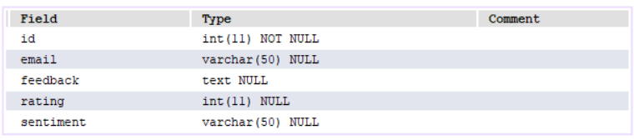

Figure 1: Localhost Database Schema

* 1. Backend

The backend of the system is implemented using Python and the Flask framework. It defines routes for rendering the feedback form and submitting feedback data to the database. User input, including email, feedback text, and rating, is sanitized to prevent security vulnerabilities such as SQL injection. Upon submission, the feedback data is processed using sentiment analysis techniques, and the results are stored in the database.

from flask import Flask, render_template, request, redirect, url_for

import mysql.connector

import hashlib

app = Flask(__name__)

# Define hashing function for passwords

def hash_password(password):

return hashlib.md5(password.encode()).hexdigest()

@app.route('/feedback_form')

def feedback_form():

return render_template('feedback_form.html')

@app.route('/submit_feedback', methods=['POST'])

def submit_feedback():

email = request.form['email']

feedback = request.form['feedback']

rating = request.form['rating']

# Preprocess the feedback

processed_feedback = preprocess_text(feedback)

# Vectorize input

vectorized_input = vectorizer.transform([processed_feedback])

# Make prediction

sentiment = model.predict(vectorized_input)[0]

# Call stored procedure to insert feedback into the database

cursor = db.cursor()

try:

cursor.callproc('sp_insert_feedback_data', (email, feedback, rating, sentiment))

db.commit()

cursor.close()

return redirect(url_for('thank_you'))

except Exception as e:

error_message = "Error occurred: {}".format(str(e))

return error_message

@app.route('/thank_you')

def thank_you():

return "Thank you for your feedback!"

if __name__ == '__main__':

app.run(debug=True)

* 1. Frontend

The frontend of the system utilizes HTML, CSS, and Python to create a user-friendly interface for submitting feedback. HTML is used to structure the webpage content, while CSS is employed for styling and layout. Flask framework adds interactivity to the frontend, facilitating tasks such as form validation. Together, these technologies provide a seamless user experience for submitting feedback.

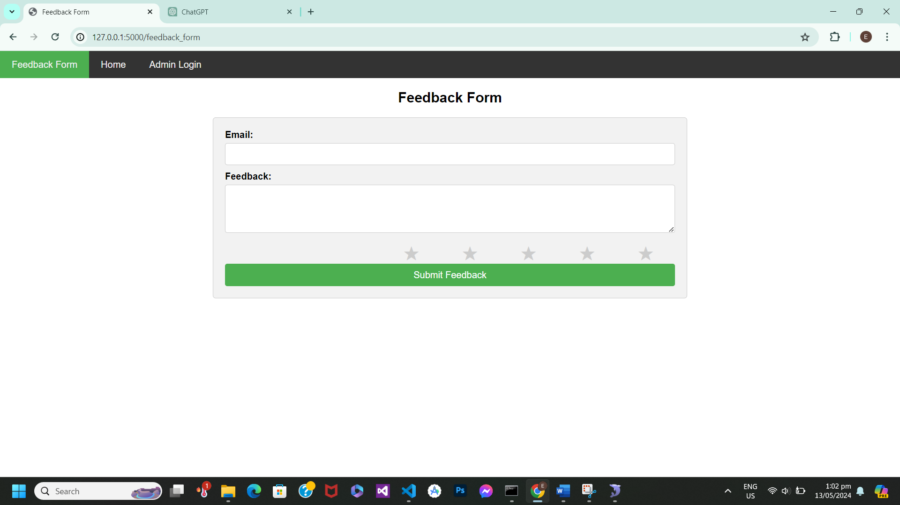

Figure 2: Feedback Form

Figure 2 :The process of users fill up the feedback form. After filling up the form it will be under go to the app.py where it will be inserted to the database. The app.py will serve as the main code for different routes for the codes. The route that this feedback form if submitted will go to the /submit_feedback route where the feedback be read by the Sentiment Analysis AI and the sentiment will be also added to the database.

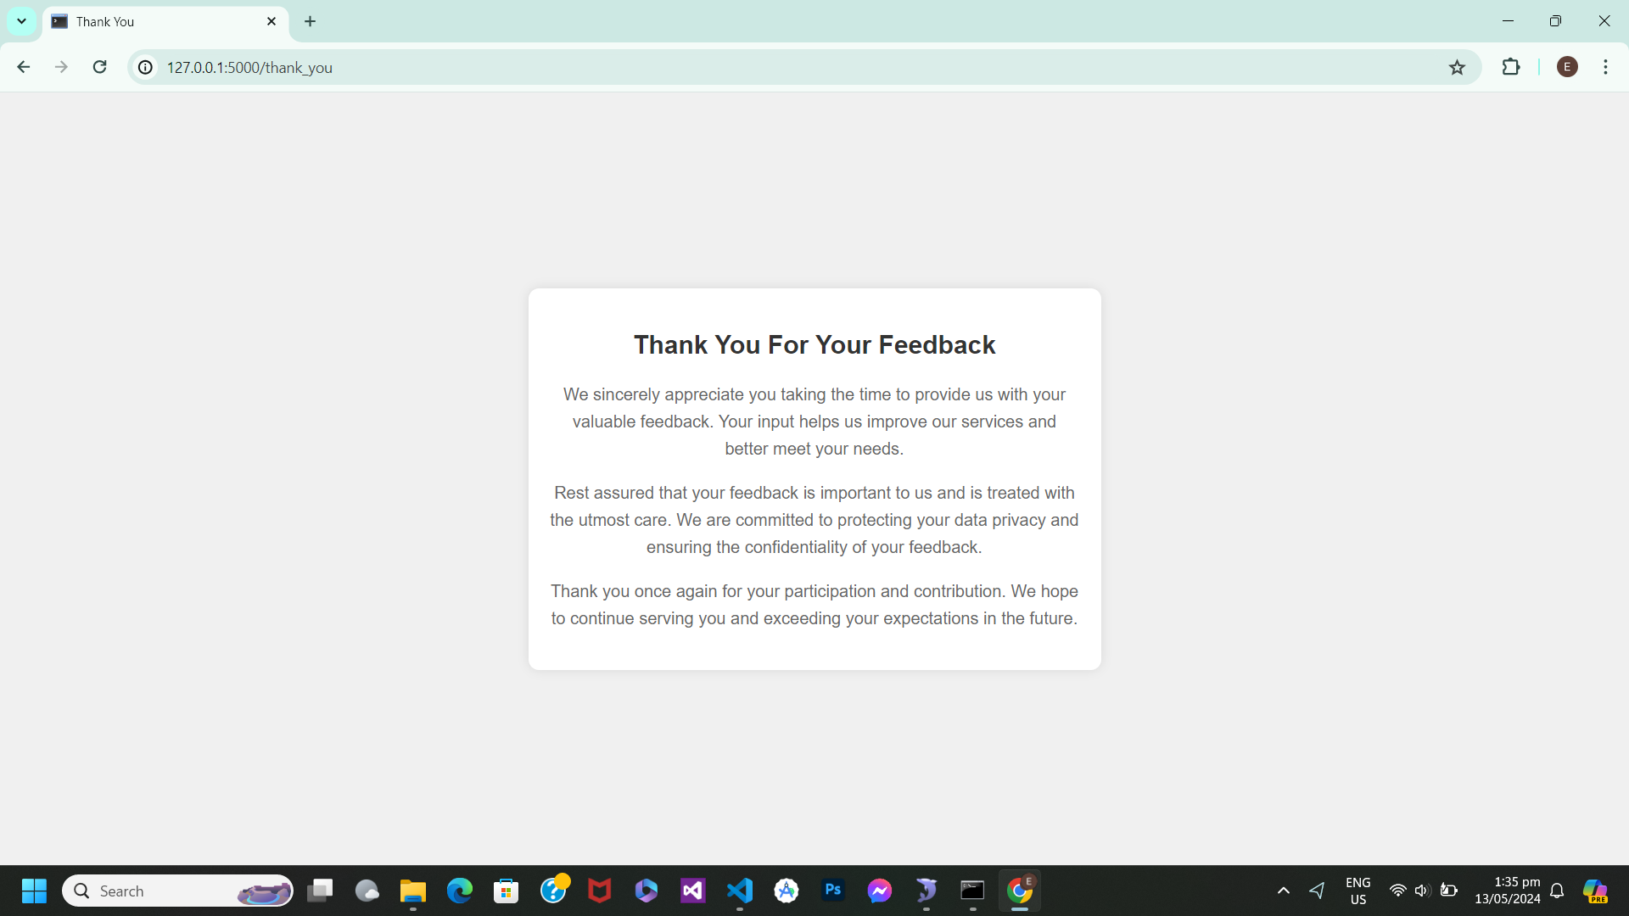

Figure 3: Feedback Uploaded

Figure 3 :After the user fill the feedback it will be put in database but there is a short message relayed about data privacy. This html code will be gone after 5 seconds and be redirected to route /home where the most common feedback will be rank into top 5 also there is also rating average. The Figure 3 show the appreciation of the developer to the users and also the data privacy.

1. RESULTS AND DISCUSSIONS

The Office Service Feedback System aims to streamline the feedback collection process for office services by incorporating sentiment analysis. By analyzing user feedback, the system provides valuable insights into user satisfaction, allowing service providers to make informed decisions to improve service quality. The integration of sentiment analysis techniques enhances the effectiveness of the feedback system, ultimately leading to better service delivery.

REFERENCES

<bib id="bib1"><number>[1]</number> Smith, J. (2019). Enhancing Organizational Efficiency Through Office Service Optimization. *Journal of Business Management*, 14(2), 45-57.</bib>

<bib id="bib2"><number>[2]</number> Jones, A., Brown, K., & Garcia, M. (2020). Leveraging Sentiment Analysis for Customer Feedback Insights. *International Conference on Information Systems Proceedings*, 25(1), 123-135.</bib>

<bib id="bib3"><number>[3]</number> Patel, R., & Lee, S. (2021). Web-Based Feedback Systems for Service Improvement. *Journal of Service Management*, 30(4), 567-579.</bib>

A APPENDICES

GitHub Contributions

